Bitstream – massive stream of 0s and 1s that tells how to open the logic gates in the fpga fabric
Bit file - it is the file that contains the bitstream
Overlay – it is the software part that loads the bit file and gives the commands to control it.
Bit stream configures the look up tables, flip-flops and routing. Routing is the connection between the LUts and the pin. LUTs are the cores or fundamental unit of fpga they decide if a block is a AND gate or a OR gate. Fli-flpos acts as traffic lights to streamline the data flow.
The IP blocks are the pre-verified circuit modules that we can drop into our design without building it from scratches. There are two types of IP blocks:
- Hard IP blocks: they are the ones that are permanently etched while manufacturing. They are incredibly fast and use zero fpga fabric.
- Soft IP blocks: they are made out of the general purpose LUTs and flip-flops. They can be made using the vitis hls. Eg: AXI DMA.
Use for pynq lib reference and block design in vivado: https://pynq.readthedocs.io/en/v2.1/pynq_libraries.html
For analog and digital pins (Arduino, raspberry and p mod) the pynq board come with a base overlay (by microblaze-an io processor) connecting all those pins to fpga fabric. But we can also do a custom remapping of those pins (hard wired which is faster than microblaze) using vivado and vitis hls.
- There is a vitis vision library for open cv to work in the fpga fabric.
Digital I/O: (Custom IP block using hls)
so, from my understanding axi gpio is an ip block and it is used to communicate between processor and pin or fabric and processor. but to directly link the fabric to pin, we need a custom IP block and make an external port and connect them both. then we make the xdc constraint file.
Analog I/O: (XADC IP block)
But it is different for the analog pins, we use the xadc ip block which directly connects the fabric to the pin available in the board. The xadc block connects the fpga fabric directly to the pin without going to the processing system.
- The XADC block has 12 bit resolution (can represent values from 0 to 4095)
But in base overlay the xadc block can be accessed by the PS to read the analog system, so whenever we use an analog signal, it passes through the PS which makes the process slow.
This can also be called acceleration but in the base overlay the PS is connected to the xadc ip block, which causes the block to have speed limits.
To create custom IP Blocks:
- Use Vitis HLS - first complete a c++ code in hls and export it as RTL file.
- Use Create and package new IP tool in vivado.

when we write the c++ code the hls creates the respective ip blocks needed, when exported as rtl. rtl is the hardware language and the vivado translates the rtl file into actual fpga components. then we import this into vivado and create bitstream and wrapper. then use the bit file and handoff file.
After completing the block design, we use the add sources option to create the xdc constraint file. The xdc file tells how the fpga fabrics are connected to the pins available in the board.

If we are not using the pynq architecture , we first create the hardware design in the vivado and do the coding in vitis ide to create the software framework.
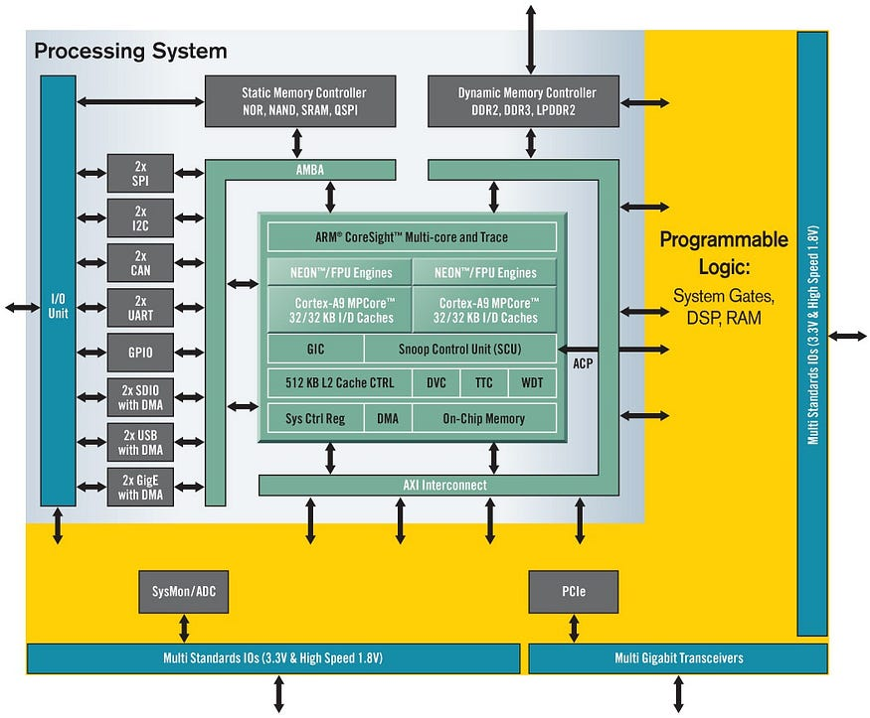

https://pynq.readthedocs.io/en/v2.3/pynq_libraries.html#ip
pynq.lib.pmod Package — Python productivity for Zynq (Pynq) v1.0

pynq.lib.pmod.pmod_adc Module
classpynq.lib.pmod.pmod_adc.Pmod_ADC(mb_info)[source]
Bases: object
This class controls an Analog to Digital Converter Pmod.
The Pmod AD2 (PB 200-217) is an analog-to-digital converter powered by AD7991. Users may configure up to 4 conversion channels at 12 bits of resolution.

